
Quotation
Quotation Number:
Date:
Customer Info. | Customer Name：
Customer Info. | Address：
Customer Info. | Contact Person： | Email：
Customer Info. | Phone： | Fax：
CIRS Info. | Follow-up Person： | Email：
CIRS Info. | Phone： | Fax：
Thanks for your support on our testing services. According to your demand, the test quotation is as follows (Euro).
Test Items | Samples | Quantity | Unit Price  (Euro) | Amount  (Euro)
Total Price
The bank information is as follows:
Beneficiary Name: | CIRS HK LTD
Bank Name: | The Hongkong and Shanghai Banking Corporation Ltd., - Tsim Sha Tsui SME Centre
Bank Address: | 4/F., 82-84 Nathan Road, Tsim Sha Tsui, Kowloon, Hong Kong
Account #: | 817-582687-838
Swift Code: | HSBCHKHHHKH

Other Remarks for Quotation：
- If no problems for test samples, please confirm and send the quotation back to us by e-mail or fax.
- Please arrange the payment to CIRS China account before the test, and send the bank receipt back to us by fax.
- Having received test fee, we will start the test at once, basing on the testing application form.


Once the test quotation is signed, it has the legal effect.
 |  | 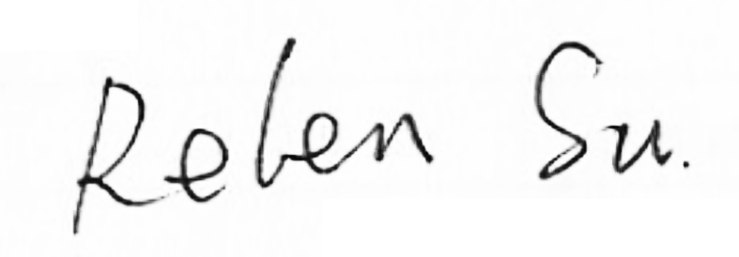
Authorized representative name: |  | CIRS-C&K testing representative name:
Signing Date |  | Signing Date

